- CRP Levels Comparison of Cases & Control (Bar Plot)
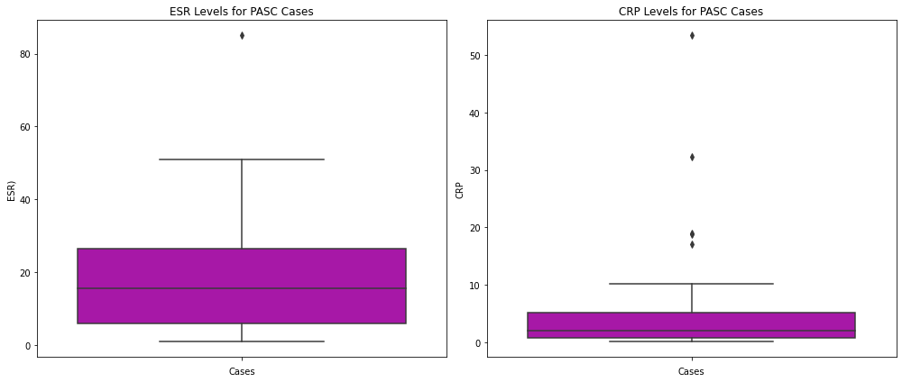
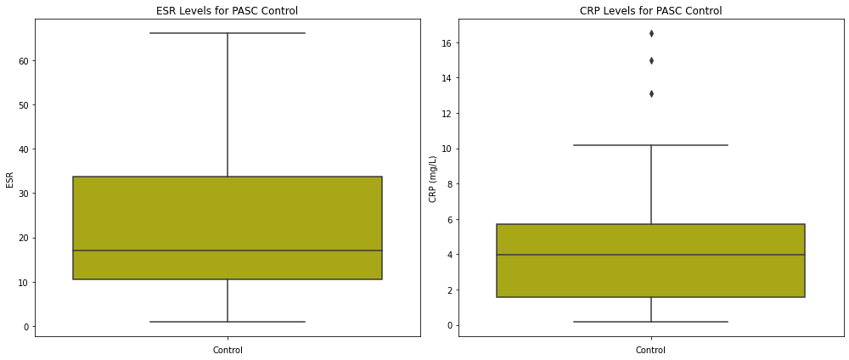

- Comparison of CRP Level of PASC Cases and Control
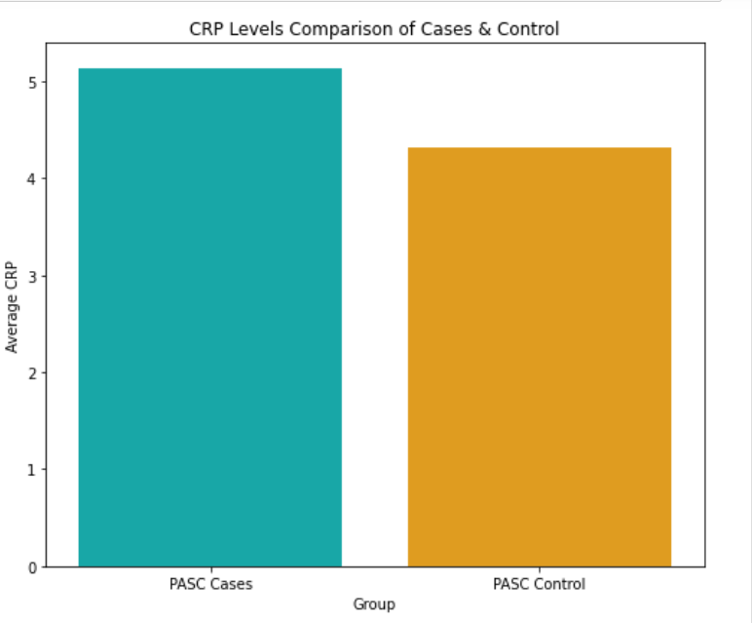s

